HDMI2USB

Booting and Reset Processes

JTAG Connections

Philosophy
Glossary
Firmware in the HDMI2USB
FPGA
Cypress
Virtual EEPROM
Explanation
How does it work?
PIC
Reset Process
Reset Signals
Reset Connections
Reset Button
Booting Process
Booting Process - Normal
Booting Process - Flash is empty
JTAG Interface
JTAG Connector Pins
Updating the Flash
FPGA to Flash Pins
Flash Contents Structure
Using Cypress as JTAG Master
Cypress to JTAG Pins
NeroJTAG and FPGALink
"Altera USB Blaster" Emulation

Philosophy

The HDMI2USB has multiple chips on the board which have firmware and could control the boot sequence.

No firmware, or firmware not booting correctly on any of the chips be recoverable from.

Invalid / corrupt firmware on any of the chips should be easily recoverable.
- We can't always be recoverable as invalid / corrupt firmware could cause pins to be held low / high.

In the case of a whole system being foobar, the Cypress USB chip should be booted without configuration allowing download of JTAG control firmware. The system should then be recoverable using JTAG control.

JTAG control should override all other power control and allow the whole system to be recoverable using it.

Glossary
- FPGA - The Xilinx Spartan 6 FPGA on the HDMI2USB
- Cypress - The Cypress EZ-USB FX2 chip (CY7C68013A) on the HDMI2USB
- Flash - The M25P16 flash chip on the HDMI2USB used to store the configuration firmware. -- W25Q128FVEIG - Serial Flash Memory with Dual / Quad SPI & QPI interface.

Firmware in the HDMI2USB

There are two pieces of firmware inside the HDM2USB device.

FPGA

The FPGA uses external firmware. The FPGA loads it firmware from M25P16 via the "Master Serial/SPI" configuration process.

The FPGA firmware is written using VHDL / Verilog and compiled with Xilinx ISE.

Cypress

The Cypress uses external firmware.

The Cypress loads its firmware from either;
- downloading via USB
- loading from "virtual EEPROM" on the I2C interface

The Cypress firmware is written in C for a 8051 processor.

Virtual EEPROM

Explanation
The "normal" way to use the Cypress is to have it be the master controller on a board. This makes sense because the system starts up when USB power is connected. In this mode;
- Firmware is loaded from a connected EEPROM chip.
  - This firmware can often be just 2 bytes containing the VID:PID information.
    - The full firmware is then loaded via the USB interface.
  - This firmware could be a fully needed information.

Unlike this typical system, the device should operate correctly before any USB is connected. The board should also continue to operate correctly no matter the state of the USB.

On a board like the HDMI2USB adding an extra EEPROM to contain the Cypress firmware isn't a great idea because;
- It adds to the cost of the board.
- It adds another location that firmware is loaded from.

How does it work?

- The Cypress-RST is held low keeping it off until the rest of the board has successfully booted.
- Once the FPGA has been successfully configured, it will pull Cypress-RST high.
- The Cypress will then see a EEPROM on it's I2C interface, provided by the FPGA.
- The FPGA takes the incoming signals and provides data from the Flash chip.

PIC

The PIC has internal flash that it loads it's own firmware from.

The PIC firmware is written in C for a PIC18f processor.

Reset Process

Reset Signals

- FPGA-RST
  - Pin V2 - PROGRAM_B_2 on FPGA.

  - When FPGA-RST is low the FPGA is in powered down state.
  - When FPGA-RST changes from low to high the FPGA will start it's booting process.
  - When FPGA-RST changes from high to low for 500 ns or longer will cause the FPGA to reset.

- Cypress-RST
  - Pin ## - RESET# on Cypress chip.

  - When Cypress-RST is low, the Cypress chip is in powered down state.
  - When Cypress-RST changes from low to high, the Cypress chip will start it's booting process.
  - When Cypress-RST changes from high to low for XXXXX, the Cypress chip will be powered down.
Most FPGA pins are XXXX when the FPGA is off.
Cypress pins are XXXX when the Cypress is off.

Reset Connections

- FPGA Pin T14 (IO_L12P_D1_MISO2_2) is connected to PIC-RST
- FPGA Pin P3 (IO_L2N_3) is connected to Cypress-RST

- Cypress Pin ## (PD1 / FD9) is connected to FPGA-RST

Cypress-RST is connected to an RC circuit, if neither the PIC for FPGA pull the pin low, the Cypress will boot after X_{failsafe} seconds.

Reset Button

The reset button should;
- Reset the FPGA
- Reset the Cypress
- Then the complete system should boot as if power was just connected.

Booting Process

PIC -> FPGA -> Cypress

Booting Process - Normal

The primary boot sequence will be;

- Power comes on.

- FPGA boots, loading it's configuration from the Flash chip.
  - FPGA pulls Cypress-RST low, preventing the Cypress booting.

- At this point the FPGA is operating normally and the HDMI signals are being processed.
- FPGA is "ready" for USB.
  - FPGA pulls Cypress-RST high, causing the Cypress to start booting.
- Cypress starts booting, loading it's configuration from Virtual EEPROM provided by FPGA.
- The system is now a valid HDMI2USB device and is communicating with the host via USB.

Booting Process - Flash is empty

- Power comes on.

- FPGA tries booting, but fails to load from Flash.
- After t3+X_{failsafe} seconds, the RC circuit on Cypress-RST reaches high state.
- The Cypress boots but is unable to find an EEPROM as the Xilinx is off. The Cypress boots as an unconfigured "Cypress USB Chip".
- Firmware can now be loaded using the "Firmware Updating: Using Cypress USB Interface" process.

JTAG Interface

The JTAG interface is connected to the FPGA, no other devices on the board are JTAG compatible.

Neither the Flash nor the PIC chip support JTAG, however special firmware can be downloaded to the FPGA which will allow them to be configured.

JTAG Connector Pins

The JTAG interface can be found on connector P1 which should be clearly marked on the silk screen. The JTAG connector pins are laid out in a manner compatible with the Xilinx Platform cable.

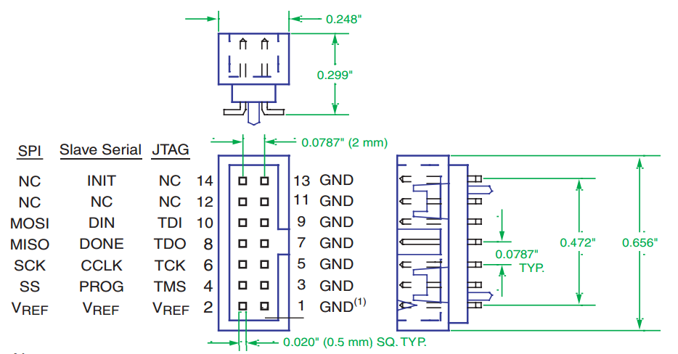

Updating the Flash

- Load "program flash firmware" onto FPGA.
  - FPGA programs the Flash chip.

Process is shown in the http://numato.com/productdoc/mimas/MimasSpartan6Module.pdf

FPGA to Flash Pins

FPGA Pin  Pin # - Using As  Full Pin Name | Flash Pin | Net Name | Pull state | Description
N/A | W#  Write protect |  | Up or Down | Connected to header JXX.  Enable writing; jumper pins 1 and 2.  Disable writing; jumper on pins 2 and 3.
N/A | HOLD#  Hold |  | Up | Not used in our device.
R15 - Configuration Clock  IO_L1P_CCLK_2 | C  Serial data clock | SPI-SCK | ??? | Serial clock.  FPGA is master, Flash is slave.
T13 - Master FPGA Serial Data Input  IO_L3N_MOSI_CSI_B_MISO0_2 | DQ0  Serial data input | SPI-SDO | ??? | Serial data from FPGA->Flash.
R13 - Master FPGA Serial Data Output  IO_L3P_D0_DIN_MISO_MISO1_2 | DQ1  Serial data output | SPI-SDI | ??? | Serial data from Flash->FPGA.
V3 - Master SPI Chip Select Output  IO_L65N_CSO_B_2 (Active Low) | S#  Chip select | SPI-CS-FLASH | Up | Chip select from FPGA->Flash.
T15 - Mode configuration pin M[0]  IO_L1N_M0_CMPMISO_2 | N/A | M0/  RESET | Up | Sets FPGA to use "Master Serial/SPI" (M[1:0] == 01) mode for configuration.
N12 - Mode configuration pin M[1]  IO_L13P_M1_2 | N/A | M1/  EXP-IO16_P | Down | Sets FPGA to use "Master Serial/SPI" (M[1:0] == 01) mode for configuration.

Flash Contents Structure

The data loaded into the flash is two parts;
- FPGA firmware
- Padding / EOF marker
- Cypress firmware

The FPGA firmware section must be first, as the FPGA will be reading in the data directly from the flash.

Location | Contents
 | Device ID
 | FPGA Configuration Data
 | CRC
 | Marker
 | Virtual EEPROM marker / header
 | Cypress VID:DID
 | Cypress Firmware
 | Marker
Empty Space
Empty Space
Empty Space
 | Non-volatile logs (Grows from last flash frame downwards)

Using Cypress as JTAG Master

The Cypress chip is connected to the JTAG pins on the FPGA and hence can be used to program the FPGA.

Cypress to JTAG Pins

Rows in Orange are informational only and not involved in the JTAG process.
Rows in Green are extra pins useful in the JTAG process but not part of the specification.

FPGA Pin  Pin # - Using As  Full Pin Name | Cypress Pin | JTAG Pin | Description
F13 - TDI (SLX45T)  D15 - TDI (SLX16) | PD0 / FD8 | TDI  (Test Data In) | Data from Cypress+JTAG header into FPGA
V2 - FPGA-RST  PROGRAM_B_2 | PD1 / FD9 | TRST  (Test Reset) | Puts FPGA into programming mode
D16 - TDO | PD2 / FD10 | TDO  (Test Data Out) | Data from FPGA into Cypress+JTAG header
B18 - TMS | PD3 / FD11 | TMS  (Test Mode Select) | Signal from Cypress+JTAG to FPGA
A17- TCK | PD4 / FD12 | TCK  (Test Clock) | Clock from Cypress+JTAG header into FPGA
N/A | PD5 / FD13 | N/A | Status LED
U3 - INIT_B IO_L65P_INIT_B_2 | PD6 / FD14 | N/A | Held Low to delay configuration, afterwards CRC Error.
V17 - DONE_2 | PD7 / FD15 | N/A | Asserts high when the FPGA is configured.
P3 - GPIO IO_L2N_3 | RESET# | N/A | Cypress Reset Pin

NeroJTAG and FPGALink

The Cypress is connected to the JTAG bus in a way compatible with the open source NeroJTAG.

This set up is also identical to the connection Cypress chip on the Digilent Atlys and Nexys2 boards.

- Load NeroJTAG firmware onto the Cypress. This can be done via;
  - Using a tool like fxload / fx2loader to load the .hex file directly.
  - Using the libfpgalink library or command line tools (which include the .hex internally).

- Cypress chip is now a NeroJTAG device and controlling the JTAG interface.
The firmware needed for the Cypress can be found at https://github.com/makestuff/libfpgalink/tree/master/firmware/fx2

"Altera USB Blaster" Emulation

The Cypress is compatible with our custom version of the fpga4u fork the usbjtag project. When this firmware is loaded the Cypress chip will appear as an "Altera USB Blaster" and can be used with any software which is compatible such as Xilinx Impact tools.

- Load our custom version of the usbjtag firmware onto the Cypress. This can be done via a tool like fxload / fx2loader to load the .hex file directly.
- Cypress chip is now a "Altera USB Blaster" device and controlling the JTAG interface.

From http://www.xilinx.com/support/documentation/user_guides/ug380.pdf Hold the FPGA PROGRAM_B pin Low from power-up to delay the start of the FPGA configuration procedure and release the PROGRAM_B pin to High after the SPI flash is fully powered and is able to receive commands.
When S# input signal is HIGH the device is deselected and DQ1 is at HIGH-Z

